**WEEK-8**

**2. Git - HOL**

* Explain git ignore

.gitignore is a special file used by Git to tell it which files or folders it should ignore and not track in the repository.

* Explain how to ignore unwanted files using git ignore

To ignore files, create a .gitignore file in your project folder and list patterns of files or folders you want Git to skip, such as *.log for all log files or logs/ for a specific folder.

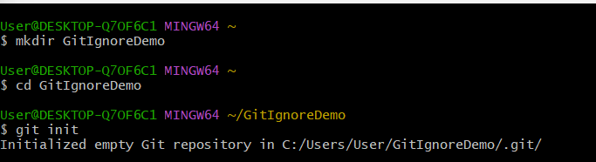

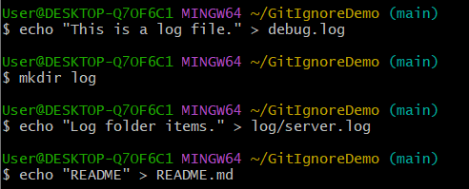

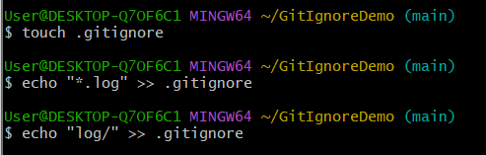

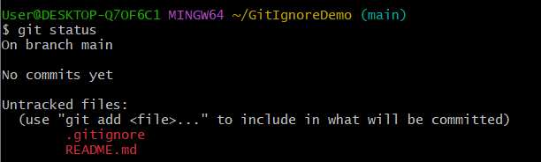

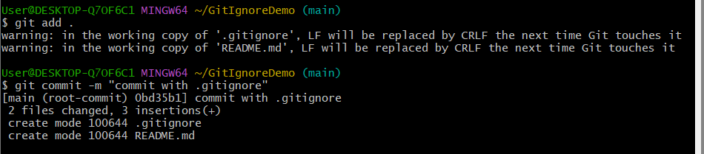

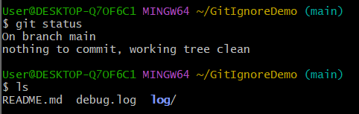

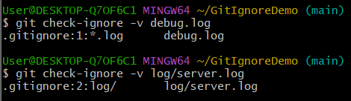

**Explanation:**

* First, I made sure my Git repository was already set up in the working directory.
* I created a **sample .log file** (e.g., error.log) inside the working folder to test the ignore functionality.
* Next, I created a **folder named log** and placed another file inside it, just to check if Git will ignore the entire folder.
* I opened or created a .gitignore file in the root of my repository.
* Inside .gitignore, I wrote *.log to tell Git to ignore all files with the .log extension.
* Then I added log/ on a new line so Git will completely skip tracking the log folder.
* After saving .gitignore, I ran git status to check — now the .log file and the log folder were not listed as untracked files.
* This confirmed that Git successfully excluded them from tracking.
* I committed my .gitignore file so these ignore rules are part of the repository for everyone who works on it.
* Now, even if I create more .log files or add content inside log/ folder, Git will continue ignoring them automatically.